**INTRODUCTION**

**CLIENT BACKGROUND**

Sky Gym fitness is located in Kandy which was established in the year 2015. They currently have 1643 registered members at their gym out of which approximately 30% are active members. Sky Gym has a variety of workout schedules sub-divided in few categories and for each schedule they have a trainer in charge of it. All the trainers who are employed at Sky Gym are part time workers and currently they have 18 trainers working with them.

Sky Gym is equipped with highly sophisticated equipment and they hold an inventory count of 723 which includes weights, benches, dumbbells, kettlebells, gym balls and fitness equipment.

**PROBLEMS & SOLUTIONS**

1. **Handling customers and trainers**

Handling the employees and customers are the most challenging task Sky Gym is currently facing. They do not have proper records of their customer fee payments and trainer salary payments. Due to this problem they have had incidents where they had misunderstandings between their customers and trainer- especially with trainers.

In addition to this they also do not have proper records of their customers also they have misplaced some of the past records.

**Solution**

Employee management will help to store all trainer and customer information and retrieve them whenever needed. As a result they will be able to manage the gym efficiently and more effectively.

1. **Marketing the Business**

**Problem**

Currently the client is following the traditional way of marketing the gym such as posters and leaflets.

**Solution**

Online gym store makes it easier for both our client and their customers. Our client does not need to spend time designing poster to cover all their facilities and amenities as they are able to show up all their facilities using this web application. In the customers point of view they too will have a better idea about the gym if they browse our web application.

In addition to that it is easier for potential customer to navigate to the web page and check for the services offered by Sky Gym rather than visiting the gym to get the information.

1. **Diet Plans for Customers**

Problem

Customers currently do not follower a proper diet plan since the gym does not provide any suggestions. However, majority of the customers had requested for a healthy food plan and the trainers at the gym used to randomly suggest diet plans

**Solution**

Food diet management of our system suggests diet plans for the members at the gym depending on their age, weight. However, customers are yet free to choose other dietary plans based on their requirement.

1. **Schedules**

**Problem**

Currently the customers at Sky Gym do not have a way to track their workout progress. Besides this the members, especially new members, do not knowledge about their schedules.

**Solution**

Schedule management in our system helps the customer to know his/her schedule. Moreover, they will be suggested with suitable schedules depending on their weight and age.

1. **Inventory and stock management**

**Problem**

Purchase of store goods and payment made by customers manually recorded, they are not maintained properly, client request a solution to check the overall monthly stock. Moreover, they have had instances where their equipment such as dumbbells were stolen. So they did not realize it for a long time and were too late when the realized it.

Solution

Online store manages the availability of goods and inventory management handling the payment and keep record of each transaction and update inventory management when goods are out of stock.

1. **Bill payment**

Problem

The bills of the gym are handled manually and Sky Gym does not have a proper knowledge about the bill expenses done. This problems prevents them from identifying the realistic profit/loss generated by the gym overtime.

Solution –

Financial management system helps to keep records of bill payments and online transactions and produce monthly income and expenditure of the gym.

**BENEFITS OF THE SYSTEM**

Our online gym store system has many benefits for Sky Gym. In addition to the solutions given to the problems the gym has key benefits when considering the gym as a whole. The most significant benefit is that the administrator has less work and the gym can be maintained and controlled more efficiently. Moreover, the system maintain a proper records of all aspects of the organization and also enables to generate reports. This will help them to review their performance, identify instances where they can improve and finally produce better results.

Furthermore, this system makes it more convenient for the trainers and the customers of the gym.

**SYSTEM OVERVIEW**

**SKY GYM Online Management System**

**Member**

**Trainer**

**Adminraor**

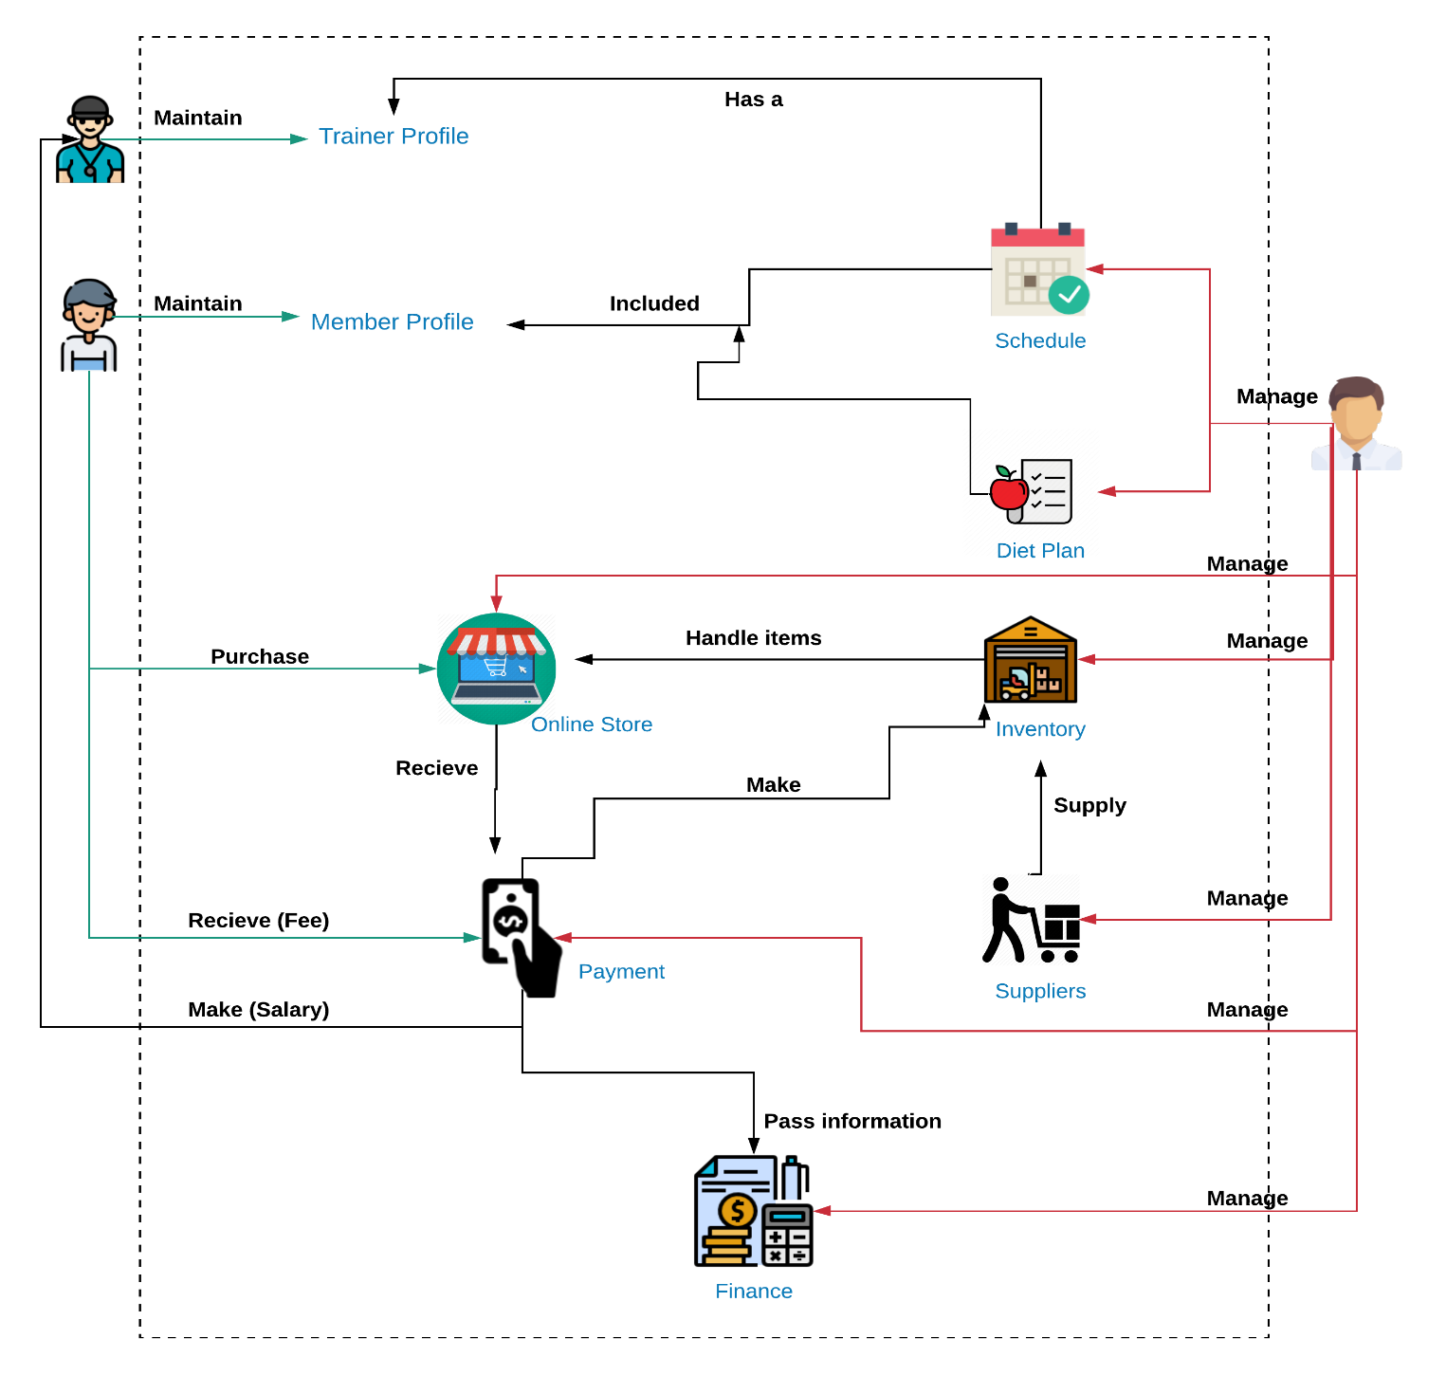



**System Database**

**FUNCTIONALITIES**

The system consists of 8 major functionalities. The functionalities are divided into 3 perspectives which are the trainer’s side, administrator’s side and the customer’s side for better understanding of each functionality and how it may apply in practical context.

1. **Customer Management System**

**Customer Side**

The customer can directly register by signing up to the system by entering the required details. But to activate their account they have to make the payment to the gym only then the administrator will activate his/her profile.

Once the customer logins into his/her account they will be able to view their current schedule and their workout progress of that particular schedule. They will be able to mark their daily attendance. Whenever, they mark their attendance the workout progress of the current schedule will increase. Initially the member will be assigned with a beginners’ schedule by default. Once the customer is done with a particular schedule the system will suggest a new schedule or else the customer will be able to continue with the same schedule.

Moreover, a registered member will be able to update their personal information such as their age, weight, password and profile picture.

**Administrator Side**

The administrator has the authority to update and delete customer information. Therefore if a member has not paid for three months the admin will be able to disable their access to their profile until the member makes the payment. The search function helps the administrator to search for a customer by their name or Membership ID.

Moreover, the administrator can generate monthly reports of membership reports and a report based on the gender.

1. **Schedule Management**

**Customer Side**

Schedule management as a function will allow the customer to select a schedule depending on their personal preference and requirement. However, the beginners’ schedule will be the initial schedule to any member. Once a member completes the first schedule they will be able to switch to a new schedule. The user will be suggested a few schedules based on their age and gender. However, the member has the freedom to choose other schedules.

Overall the schedule will categorised into 4 different type as follows:

1. Weight loss
2. Muscle building
3. Cardio
4. Calisthenics

**Administrator Side**

The schedules available for the members can be updated, edit and deleted by the admin. A schedule can be deleted only if there are no customers using that particular schedule. Besides this the system allows the administrator to search for a specific schedule with the name of the schedule. Finally the administrator has the ability to generate reports of schedules as follows:

* Overall report
* Schedule based reports

Besides this the administrator has to assign a trainer to a particular schedule based on the area that they are specialized in (weight loss, muscle building, cardio or calisthenics).

1. **Employee Management**

**ADMINISTRATOR SIDE**

Only the administrator can add, update and delete employees and administrators of the system. When trainer profiles are created they will be given an auto-generated or a default password which they can later change as per their preference.

Administrator will mark the attendance of all the employees (administrators and trainers).

In addition to that, the administrator will also be able to search a trainer using the trainer ID or the schedule that particular trainer is handling.

The administrator shall calculate the salary of a trainer which includes his/her overtime earnings (salary + overtime).Therefore, the administrator can update the overtime hours of a trainer. Employees can be dividing as specialisation (schedule). Specialisation to specialisation bonus, allowance and over time rate are different. So that administrator can add, update, delete and view specialisation category list. All the input fields are validated by the system.

Finally, the administrator can to generate salary reports individually and an overall report of all employees but only the overall report will be stored in the system and the individual employee reports will be only for reference purposes.

**TRAINER'S SIDE**

In the trainer’s side he/she can update limited information such as personal information, image, biography, password etc. The trainer will also be able to view the trainees that he/she is in currently responsible for.

1. **Payment Management**

When a member registered to the gym they will have to select a payment scheme. Following are 3 payment methods currently available at Sky Gym:

1. Monthly Basis
2. Six Months
3. Annual Basis

The administrator has the ability //**add new schemes//** and update or remove the existing schemes. Administrator also has to keep track of the payments of the members. In case a member has a due administrator can notify him/her about the due. If payment is made after the expiration of the account detail should be updated.

The administrator should be able to search the customer’s payments history/details by typing the customer name and should be able to enter the receipt number and search which customer did that payment.

Reports on the payment made can be generated (This could be an overall report or report of a single member or both).

1. **Online Store**

**Customer Side**

The store is available only for the registered members of the gym. Members can view and add the products they need to the cart and if they wish to purchase they can checkout and a bill will be displayed. There after they can make the payments at the gym and get their items. The customer can search the products he/she needs by entering the name of the product.

**Admin Side**

The store inventory will be handled by administrator (inventory displayed at store excludes inventory in warehouse). The payments made to the online store will be handled and recorded in this section of the system.

1. **Inventory Management**

**Administrator Side**

Inventory management helps to keep track of all the inventory of the gym. The administrator can add, update and delete inventory in the system. In addition to that after an estimated period of time the system will show up for an equipment maintenance request through which he/she will be able to request for maintenance.

**Customer Side**

Customer will be able to view the equipment available at the gym.

1. **Diet Plan Management**

**Administration Side**

The administrator can add, update and delete diet plans for the members to use. These diet plans will be stored in a PDF file in the database. Diet plans will be categorised as following:

1. Weight Loss
2. Muscle Building
3. Athlete
4. Cardio / Calisthenics

The admin can also search for a particular diet plan using the name of the diet plan or the diet plan Identification Number (ID).

Finally the administrator will be able to generate a report based on the categories chosen and an overall report of all the diet plans.

**Customer Side**

The customer will be able to pick a diet plan based on his/her motive and preference. In the meantime the system will suggest a few diet plans to the member based on their Body Mass Index (BMI). However, the member is free to choose other diet plans regardless of what he/she is suggested with

**Administrator Side**

Finance Management as a functionality will help the administrator to maintain proper accounts of income and expenses. The administrator will be able to calculate the total income and expenses of the organization and finally calculate the overall profit/loss of the business. The expenses include the salaries of the trainers, bill payments, and store inventory payments whereas incomes includes customer membership revenue and income earned through the gym store.

Finally the administrator can generate annual and monthly reports using the available figures.

1. **Finance Management**

**Administration Side**

Finance management functionality allows the administrator to calculate the total income and expenses of the gym. The income of the gym includes the income earned through the gym membership and the gym store. Whereas expenses of the gym are the bills of the gym, store item purchases, and the trainer salaries. Therefore, using these figures the administrator can calculate the profit of the gym and generate monthly and annual reports. In addition to this the user will be able to search for a report by entering the year of the report.

**TECHNOLOGIES**

* JavaScript
* C# - Asp.Net
* MySQL

1. **Report Management**

**Administrator Side**

This functionality will allow the administrator to manage the reports obtain through other functionalities. The administrator can add and delete reports from the system.

**GANTT CHART**

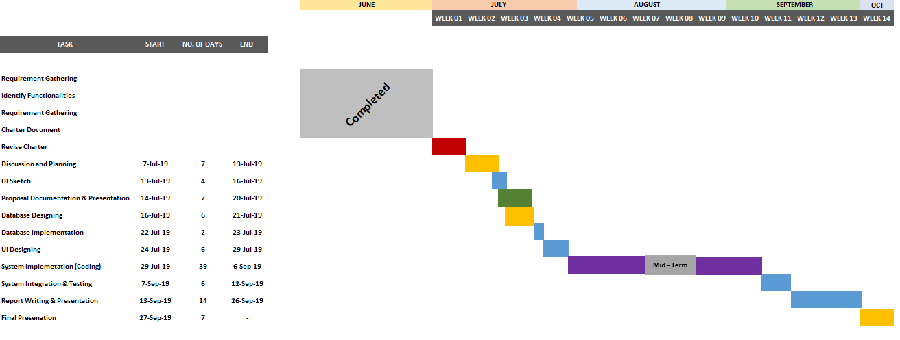

**TASK DISTRIBUTION**

|  |  |  |
| --- | --- | --- |
|  | **Name with Initials** | **Brief Description of the Function** |
|  | Z.M.M. Akaam |  |
|  | Sangeeth Raj .A | **Employee Management(Minor staff and Trainers)**  Profile Creation  Mark Attendance  Calculate salary  Generate reports  Search Employee |
|  | Krishnamoorthy.N | **Schedule Management**  Add/Update/Delete Schedules  Suggest Schedules according to weight and gender |
|  | Edirisinghe E.N.V | **Inventory Management (Supplement Store & Gym)**  Add/Update/Delete Inventory  Re-Order Inventory  Search Item |
|  | Jayasooriya D.C. | **Diet Plan Management**  Add/Delete/Update Diet Plans  Suggest Diet Plans according to User’s weight & gender |
|  | J.L Thilini Randika | **Customer Management**  Mark Attendance  Add/Delete/Update Workout Information  Generate Workout Reports  Profile Creation  Update his/her information  Search Member |
|  | Devduni.R.M.B | **Payment Management**  Process Payments (Membership and Bill payments)  Notify Dues  Make Payments |
|  | Imalsha Kavindi K.G. | **Finance Management**  Add/Update/Delete Income & Expenditure  Calculate Net profit  Generate Monthly and Annual Reports |